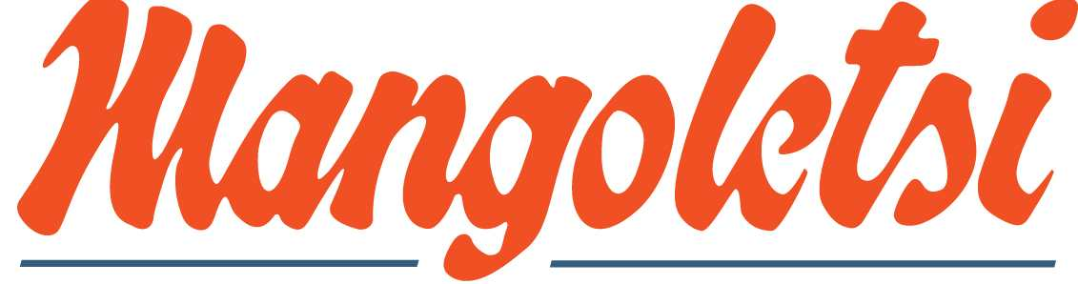

NEW INNOVATIONS FOR CLASSIC CARS
DESIGN

COMPARISON OF AFTERMARKET DATSUN 240/260/280Z INLET MANIFOLDS FOR WEBER AND INJECTION CONVERSIONS.

There is a fundamental problem with obtaining a new manifold that fits the many different Z cylinder head OE castings. The original heads have varying port centres and port dimensions – even the heights and widths of each port can vary substantially. The manifold stud centres, such as they are, also vary with the port centres.

The existence of this problem is confirmed by Datsun, as the standard inlet manifold is manufactured in two halves, with an adjustable screwed rod in between them, to attempt to improve port matching.

SPECIFIC ADVANTAGES OF MANGOLETSI INLET MANIFOLDS.

Casting Design
As the engine is not a cross flow design the inlet manifold does not benefit from a one piece head face flange. Comparison with other well known manifolds will show the substantial lengths we have taken to strengthen the manifold through webbing and ribs. The casting is of the highest quality, produced to BS9001 quality standards, on the same production line as Aston Martin heads and other major components. It is well known for aftermarket 240/260/280 Z manifolds to distort in casting and in use.

Port Design
The 40 and 45mm port designs are dedicated to the specific manifold and, with the new 45mm version, we have combined extremely good low down torque with high power output. Quote from Steve Kiddell - . I attribute a significant amount of my 294 hp to this setup as the latest runner design directly influences mid range cylinder fill.

Port Centres and Matching
The ports are polished, normally a process other manufacturers leave to the engine builder. We can do this accurately because we control the port centres. The problem of the varying OE port centres, diameters, etc. has been solved by an unique approach via our new port matching system. If necessary this can be achieved with the engine still in situ with the template, flap wheel and drill supplied. The port template can be used to reverse engineer the head port to manifold matching, where the customer already has a big port head, which may not have consistently accurate port positions. Quote from Steve Kiddell - , we were able to set the entire thing up (in situ) to the head port, matched to a high standard and doweled in about two hours, remarkable, , in “other” installations this has taken significantly more time and none were better.

Linkages
The Z linkages are renowned for their lack of response through the lost motion in the many connections and various operating angles of the standard ball joints, swivel trees, etc. There is a constant debate about the merits of both the rod and cable systems – to ensure that our customer has the very best option that suits his requirements, we supply both systems as standard.

A fundamental part of the design is the use of aircraft quality rose joints (which have zero lost motion) in place of the normal ball joints. So our rod linkage, if used, has an advantage over other systems. However it is generally accepted by our customers that the Mangoletsi twin cable linkage provides superb and highly controllable throttle response. A quadrant assembly is attached via a cast bracket to the bulkhead and the CNC quadrant runs on a stainless shaft on an oilite bush. The twin cables connect via a CNC bracket on the manifold to the linkage cross shaft attached to the manifold via 3 rose joints. An adjustable pedal cable stop prevents overload. The aluminium billet levers are clamped and screwed into the cross shaft, and with the Left and Right hand threaded rose joints giving precise and quick carburetor matching. The unique adjustable pedal travel set-up enables the driver to select the throttle response that he requires. Quote from Steve Kiddell - The jewel in the crown is the new linkage setup that John (Mangoletsi) has developed Steve Kiddell (Santa Pod record holder)

Quality
The basic design, attention to detail and very high specification of all components bring about a standard of quality which is now being accepted as well in advance of any other kits on the market. When comparing our price, which in many cases is only marginally more expensive, what you get in terms of specification and certainly in terms of quality and results, provides great value for money.

Unit F, Springvale Court, Moston Road, Sandbach, Cheshire CW11 3HL
Tel: 01270 750 502 Fax: 01270 750 506
jmangoletsi@yahoo.co.uk
Registered in England Co. no. 2771911

